Operating Systems ASSIGNMENT 1
CO1: Apply the concepts of operating system types, structures and system calls to demonstrate their functions in various computing environments – history of operating systems, mainframe, desktop, multiprocessor, distributed, clustered, real-time and handheld systems, OS structure, services, system calls, system design, CPU states, memory hierarchy and I/O systems.

Assignment Title: Evaluate and Justify the Operating-System Design of a Smart Hospital (Total Marks - 50)
Nature of Assignment: Individual
Duration: 1 Week
Submission Date:
Bloom’s Levels Assessed: K5 – Evaluate (every task in this assignment is at K5 level)
Mandatory Execution and GitHub Submission
- Every student must individually execute every task in this assignment, including all “Complete the Code” programs.
- Create a GitHub repository named CSA04-<RegisterNumber>-Assignment1 and share it with the course faculty (public, or private with the faculty added as a collaborator).
- Keep one folder for each task (for example: Task01, Task02 … or Q1, Q2 …), containing the C source files, shell scripts, configuration files (Dockerfile, YAML), command outputs and screenshots.
- Include a README.md with your name, register number, compiler and version (for example gcc 13), the Linux distribution and version used, the exact gcc command used to compile (for example gcc -std=c11 -Wall -Wextra -pthread), the steps to run each program, and a short note of the result of each task.
- Commit your work progressively – at least one commit for each task. The commit history will be checked; a single upload of all files on the last day will not be accepted.
- Submit the GitHub link below and on the cover page of your report. An assignment submitted without a working GitHub link will not be evaluated.

GitHub Repository Link: https://github.com/192524372simats/CSA0413-OS.git
How to Answer the Additional Questions
Complete the Code: Copy the given code into your repository, replace every TODO with working code without changing the rest of the program, execute it and compare your output (or result) with the expected output.
Alternative Concept and Complexity Analysis: Describe how the solution would change if the alternative concept were used, with code or pseudocode, and analyse and compare the time complexity and space complexity of both solutions using Big-O notation, supported by your own measurements wherever possible.

Scenario — Operating Systems for a Smart Hospital
A 500-bed hospital is replacing its computer systems. It needs: bedside patient monitors that must raise an alarm within 10 milliseconds of an abnormal reading; nurses’ handheld tablets; doctors’ desktop workstations; a central database server for patient records that must never stop; an imaging server that processes MRI scans using many processors; and a link to two partner hospitals that share records.
The IT team has proposed using one general-purpose operating system everywhere. The clinical staff are concerned that alarms may be delayed, the database may stop during updates, and the tablets’ batteries will not last a shift.
The number of devices may grow:
- ward (40 monitors, 10 tablets) → 1 hospital (500 monitors, 120 tablets, 80 workstations) → a group of 3 hospitals sharing records
You are required to evaluate the requirements of every part of the system, judge which type and structure of operating system suits each, examine how programs obtain OS services through system calls, and defend a complete operating-system plan for the hospital.
Design Challenge:
The hospital is adding remote patient monitoring at home and a cloud-based records service.
Re-evaluate your original design and determine whether it should be retained, modified or redesigned.

Task 1 – Requirements of Each Computing Environment

The hospital has six computing environments with very different needs. Fleet size matters too: the full hospital has about 500 monitors, 120 tablets and 80 workstations (700 clients) plus the servers, and the plan must still work when 3 hospitals share records.
  - Ranked requirement table (1 = most important)

Environment | Response | Reliability | Throughput | Battery | Security | Justification of the ranking
Bedside monitor | 1 | 2 | 5 | 3 | 4 | A missed 10 ms alarm is a patient-safety failure, so determinism comes first; a crash is next. Little data is processed (a few kB/s), so throughput is last. Battery matters during power cut/transport.
Nurse tablet | 3 | 3 | 5 | 1 | 2 | The shift (8–12 h) must be  survived on one charge; tablets hold patient data and are easily lost, so security is second.  Response time only needs to feel instant (~100 ms).

Environment | Response | Reliability | Throughput | Battery | Security | Justification of the ranking
Doctor workstation | 2 | 3 | 4 | 5 | 1 | Mains powered, many applications; the main risk is unauthorised access to  records, then interactive responsiveness.
Database server | 3 | 1 | 2 | 5 | 2 | 'Must never stop': availability dominates.  Many concurrent transactions (throughput) and strict confidentiality follow. Power is not a concern.
Imaging (MRI) server | 4 | 3 | 1 | 5 | 2 | MRI volumes are hundreds of MB; fast parallel processing is the goal. A re-run after a  failure is acceptable, so reliability ranks below throughput.

Environment | Response | Reliability | Throughput | Battery | Security | Justification of the ranking
Partner link | 3 | 2 | 4 | 5 | 1 | Records cross organisational boundaries over a public network: authentication, encryption and audit outrank everything else.

Conflicting requirements
    - Fast response vs many users on one machine: time-sharing gives every user a fair slice, which makes the delay for any one task unbounded under load. A monitor therefore cannot share its CPU with general programs.
    - Throughput vs response time: large time-slices and big batches raise throughput (fewer context switches) but increase latency; the imaging server favours batching, the monitor the opposite.
    - Battery vs performance and security: encryption, rich services and high clock speeds drain tablets; the OS must use power states and hardware crypto.
    - Availability vs updating: security patches usually need a reboot; the database server needs rolling updates across a cluster so that updates never stop service.
    - Security vs ease of use: strong authentication slows clinicians in an emergency; break-glass access with full auditing is the usual compromise.

Requirements critical to patient safety
Highest criticality: (1) the monitor's bounded alarm latency (10 ms) and its freedom from crashes; (2) availability and integrity of the patient database (wrong or unavailable allergy/medication data can harm a patient); (3) confidentiality of records (legal and ethical). Throughput of the imaging server, tablet battery and workstation convenience are important but not immediately life-critical.

Lessons from the history of operating systems

Era | Key idea | Where it applies in the hospital
Batch (1950s-60s) | Run jobs one after another without user interaction; maximise throughput | Imaging server: queue of MRI reconstruction jobs; nightly backups and report generation on the database server
Time-sharing (1960s-70s) | Many interactive users share one CPU via time-slices; protection between users | Database server and workstations: many clinicians use shared resources; user/kernel separation, file permissions
Personal computers (1980s-) | One user, good GUI, low cost, little protection originally | Doctor workstations: responsive GUI; lesson: lack of early protection led to malware, so modern desktop OSs must enforce isolation
Mobile / handheld (2000s-) | Power management, touch, always-on networking, app sandboxing | Nurse tablets: Android-style reduced services, aggressive sleep, per-app permissions
Real-time / embedded | Correctness depends on meeting deadlines | Bedside monitors: deterministic scheduler, tiny footprint

Alternative concept: one general-purpose OS on every device
Solution. Install a standard time-sharing OS (for example a stock desktop/server Linux or Windows) on every monitor, tablet, workstation and server, administered as one image. Evaluation:

Criterion | Single general-purpose OS everywhere | Different OS per environment (proposed)
Worst-case alarm response | No guaranteed bound. Under heavy load, with a fair scheduler, page faults, swapping and long kernel paths, delays of tens to hundreds of ms are possible: O(unbounded) in theory. Fails the 10 ms requirement. | Hard RTOS with priority pre-emption: interrupt latency + context switch of microseconds; worst case is bounded and analysable: O(1) scheduling with a fixed deadline.
Memory per device | Typically 512 MB–2 GB RAM and several GB of disk per monitor, plus a GUI stack nobody uses | RTOS image 10–500 kB flash, 16–256 kB RAM, so each monitor needs far cheaper hardware and uses less power.
Administration | One image, one toolset, one skill-set (advantage), but the update window affects all 700+ devices and every monitor needs the patch-and-reboot cycle of a large OS | Four or five OS families, more skills needed, but the small RTOS has few updates and the critical systems are isolated from desktop malware
Battery (tablets) | Desktop power model, full services: shorter shift | Reduced handheld OS tuned for sleep
Space/time complexity | Memory O(S x D) where S = full OS size, D = devices | Memory O(sum of S_i x D_i) with S_i small for the 500 monitors
Evidence: Ranked requirement table (1.1) with justification, conflict analysis and the single-OS comparison (1.5).

Task 2 – Type of Operating System for Each Environment

Types compared

Type | Main characteristics | Hospital suitability
Mainframe | Batch + transaction processing, extreme reliability and I/O, very high cost, proprietary | Possible for a large central database, but too costly for 3 hospitals; a cluster of commodity servers gives similar availability.
Desktop | Interactive GUI, single user, general applications | Doctor workstations.
Multiprocessor (SMP/AMP) | Several CPUs sharing memory and one OS | Imaging server.
Distributed | Machines connected by a network, OS gives location-transparent access to resources | Records shared among 3 hospitals  / cloud.
Clustered | Several nodes in one logical system with fail-over and load sharing | Database server.
Real-time (hard) | Missing a deadline is a failure; guaranteed latency | Bedside monitor alarm path.
Real-time (soft) | Deadlines are goals; occasional misses degrade quality | Monitor display, video streaming; tablets' notification alerts.
Handheld | Small screen, touch, battery management, app sandbox | Nurse tablets.

Best type per environment

Environment | Chosen type | Rejected alternatives and reasons
Bedside monitor | Hard real-time OS (FreeRTOS or QNX) | General desktop OS: unbounded latency. Soft RT only: a missed alarm is a safety failure.
Nurse tablet | Handheld OS (Android-class) | Full desktop OS: bigger footprint, poor battery, no touch design.
Doctor workstation | Desktop OS (Windows 11 / Linux desktop) | Thin terminal only: would make every consultation depend on the server.

Environment | Chosen type | Rejected alternatives and reasons
Database server | Clustered system with fail-over (Linux) | Single large SMP machine (see 2.4) or mainframe: single point of failure / cost.
Imaging server | Symmetric multiprocessing Linux, many cores + GPU | Asymmetric multiprocessing: master CPU becomes the bottleneck.
Partner link / shared records | Distributed system with replicated records over a secured WAN | Copying files by courier or e-mail: no consistency, no audit.

Symmetric vs asymmetric multiprocessing (imaging server)
    - SMP: every CPU runs the kernel and user tasks and shares memory; the scheduler balances load. MRI reconstruction splits well into slices, so speed grows nearly linearly with cores; if one core fails the rest continue.
    - AMP: a master CPU runs the OS and assigns work to slave CPUs. Simpler but the master is a bottleneck and single point of failure. AMP suits embedded controllers with dedicated roles, not the imaging server.
Decision: SMP. Limit: Amdahl's law, speed-up = 1 / ((1-p) + p/N). If 95% of the job is parallel (p = 0.95), 16 cores give about 9.1x, 64 cores about 15.4x, so memory bandwidth and the serial part limit scaling.

Clustered system with fail-over for the database server
Two or three nodes share storage (or replicate synchronously). A heartbeat message passes every ~1 s; when a node misses a few heartbeats, the surviving node takes over the service IP and database within seconds. Rolling updates: patch node B, fail over, patch node A. Result: planned and unplanned downtime are of the order of seconds.

Alternative concept: one large multiprocessor machine instead of a cluster

Criterion | Single large SMP server | Cluster with fail-over
Availability | Single point of failure: a motherboard, power or kernel failure stops the hospital. If each server is 99.9% available, the single machine has 8.8 h downtime/year; two independent nodes give 1-(0.001)^2 = 99.9999% (about 32 s/year) | Fail-over within seconds; rolling updates possible
Cost | One very expensive machine (cost grows faster than linearly with CPU and memory); the redundant spare doubles it | Several commodity servers; cost grows about linearly
Throughput vs processors (time) | Throughput grows with N CPUs until locks and memory bandwidth saturate (Amdahl, USL); lock contention can give O(N) overhead | Throughput grows by adding nodes (scale-out) but needs partitioning/replication; cross-node transactions cost network latency
Memory (space) | One large shared memory pool, simple (a 2 TB machine holds the full working set) | Memory per node; caching is duplicated, total RAM is larger
Evidence: Justified OS type for each environment (2.2) with rejected alternatives and reasons, plus SMP and cluster analysis.

Task 3 – Operating-System Structures

  - Structures compared

Structure | Description | Reliability | Performance | Ease of  updating
Simple / monolithic | All OS services in one kernel address space, calls are plain function calls | Low: a faulty driver can  crash the whole kernel | Best: one  system call, no message passing | Hard: rebuild/reboot whole kernel
Layered | Layers 0..N, each uses only the layer below | Good, easy to verify | Lower: a request crosses layers; hard to define layers | Moderate

Structure | Description | Reliability | Performance | Ease of  updating
Microkernel | Minimal kernel  (scheduling, IPC, memory); drivers, file systems run as user servers | Best: a failed driver server is restarted without a crash | Lower: messages between servers cost context switches | Best: restart services individually
Modular (loadable kernel modules) | Monolithic core + modules loaded at run time | Moderate: modules still run in kernel mode | Near monolithic | Good: load/unload without reboot
Hybrid | Microkernel design with some services in kernel for speed (Windows NT, macOS XNU) | Good | Good | Good

Structure of real systems
    - Linux: monolithic kernel with loadable kernel modules; drivers run in kernel mode.
    - Windows (NT): hybrid; microkernel-style executive layers (HAL, kernel, executive services) running in kernel mode, user-mode subsystems.
    - Android: Linux kernel + hardware abstraction layer + ART runtime + app framework; layered above a monolithic kernel.
    - FreeRTOS: very small kernel (scheduler, queues, semaphores, timers) linked together with the application; effectively a single address space (no MMU), tiny footprint of about 5-10 kB.
    - QNX: true microkernel; drivers, file systems and networking are user-space processes communicating by message passing; services restart automatically (used in medical devices and cars).

Choices for the two key environments
Patient monitor: microkernel RTOS (QNX-class) or small RTOS. Reliability and predictable latency outweigh raw speed: the sensor driver and alarm task are isolated

from the display/network stack, so a failure in the Wi-Fi driver cannot stop alarms; messaging adds only microseconds, well inside the 10 ms budget.
Database server: monolithic kernel with loadable modules (Linux). Maximum I/O and file-system speed; drivers are mature; availability comes from the cluster, not from kernel structure; modules and live patching reduce reboots.

Alternative concept: monolithic kernel on the bedside monitors

Criterion | Monolithic kernel | Microkernel
Time cost of a service request | One system call, about 0.1 µs (we measured 110 ns per getppid() call on this machine). Cost O(1), no extra context switches | Request = message to a server and a reply: typically 2 context switches plus copies, about 1-5 µs; still O(1) but 10-50x more than a system call
Kernel memory | Larger kernel image (Linux 10+ MB with modules); a trimmed embedded build several MB | Kernel of about 10-100 kB; servers added only if needed
Faulty driver effect | Driver runs in kernel mode: a bug can corrupt kernel memory or panic the whole monitor, alarms stop | Driver in user space: only that server fails, kernel restarts it (watchdog) while alarm task keeps running
Conclusion: the extra microseconds of message passing are acceptable (budget 10 ms
= 10,000 µs), while a driver crash on a monitor is not, so the microkernel is retained for monitors.
Evidence: Structure comparison against the hospital's requirements with defended choices for monitors and database server.

Task 4 – Operating-System Services
  - Service table (✔ = provided, ✖ = removed, ◐ = reduced)

Service | Monitor | Tablet | Workstation | Database server | Imaging server
User interface | o small status screen only | ✔ touch GUI | ✔ full GUI | ✖ (remote CLI /  admin tool) | ✖ (remote job submission)

Service | Monitor | Tablet | Workstation | Database server | Imaging server
Program execution | o fixed set of tasks | ✔ app lifecycle | ✔ | ✔ | ✔ parallel jobs
I/O operations | ✔ sensor, display, radio | ✔ touch, camera, Wi-Fi | ✔ | ✔ disks, network (essential) | ✔ DMA, GPU,  scanner
File system | o tiny  flash FS or none | ✔ flash FS | ✔ | ✔ journaling, essential | ✔ large-file FS
Communication | o network stack (TLS)  only | ✔ Wi-Fi, mobile | ✔ | ✔ sockets, cluster heartbeat | ✔
Error detection | ✔ watchdog, sensor checks (essential) | ✔ | ✔ | ✔ ECC,  RAID, logs (essential) | ✔
Resource allocation | o static priorities | ✔ power-aware | ✔ | ✔ CPU,  memory, I/O | ✔ NUMA/core assignment
Accounting | ✖ | o | o | ✔ audit of access | o job usage
Protection & security | ✔ secure boot, signed firmware | ✔ app sandbox, encryption | ✔ users, AV | ✔ strong (essential) | ✔

Services removed from the bedside monitor
Remove: the GUI/window system, multi-user login, general file systems and shell, dynamic program loading, printing, power-hungry accounting and the large network stack. Fewer services give a smaller image (kB instead of GB), faster boot, fewer vulnerabilities and simpler worst-case timing analysis.

Services essential for the database server
Journaling file system and I/O scheduler, process and memory management with virtual memory, networking and cluster communication, error detection (ECC memory, RAID, disk health), protection and authentication, accounting/audit, and logging for compliance.

How one patient's records are protected
    - Authentication and access control: each user has an ID; the OS checks file permissions/ACLs and role-based database permissions.
    - Address-space isolation: each process has its own virtual memory; the MMU stops a program reading another's memory (see Task 8).
    - System-call checking: open() and read() are checked by the kernel against the user's identity (SELinux/AppArmor-style mandatory access control for stricter rules).
    - Encryption at rest and in transit, plus audit log of every record access.

Alternative concept: full desktop OS on the tablets

Criterion | Full desktop OS, all services | Reduced handheld OS
Space (memory and storage) | About 4-8 GB RAM and 20-40 GB storage for OS and services; space O(number of services enabled) | About 1-3 GB RAM and 4-8 GB storage
Start-up time | 30-60 s cold boot (many services) | 5-15 s, plus quick wake from sleep
Battery life | Background services and desktop power model give perhaps 3-5 h of use | Aggressive CPU/radio sleep gives a full 8-12 h shift
Other | More attack surface, no touch design | App sandbox, remote wipe, MDM management
The figures above are typical values for these classes of system (not measured on the lab machine); the direction of the difference, not the exact number, supports the decision.

Evidence: Service table (4.1) with inclusions and exclusions justified in 4.2-4.4.

Task 5 – System Calls

  - Categories of system calls

Category | Purpose | Examples (Linux) | Hospital example
Process control | Create, run, end, wait for processes; memory allocation | fork, execve, wait, exit, brk, mmap | Shell on the database server starts a backup job
File management | Create, open, read, write, close files | open, read, write, close, unlink | Reading a patient record file
Device management | Request, read, write devices | ioctl, read, write on  /dev/* | Reading the ECG sensor
Information maintenance | Get/set time and attributes | getpid, gettimeofday, stat | Timestamp for an alarm
Communication | Message passing / shared memory / sockets | socket, send, recv, pipe, shmget | Monitor sends alarm to nurse station
Protection | Permissions and access | chmod, chown, setuid, umask | Restricting a record to its doctor

What happens during read(fd, buf, n)

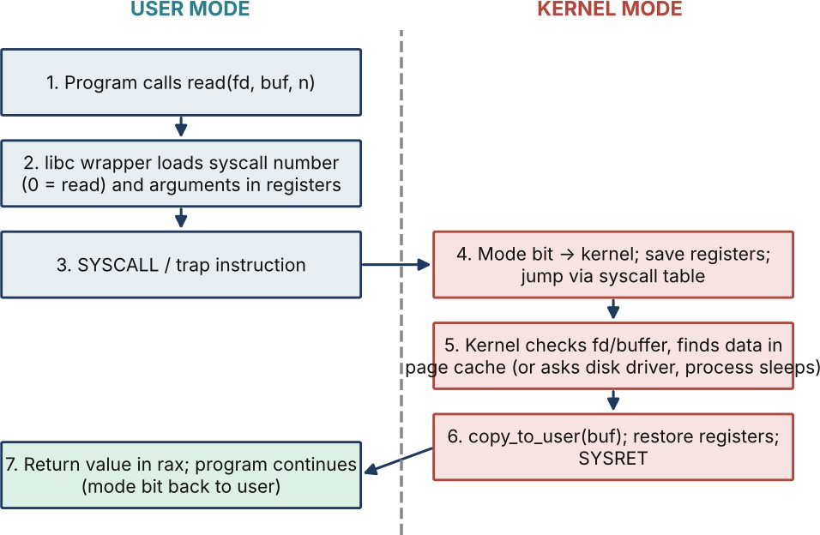

Figure 5.1 – Step-by-step path of a read() system call

    - Library call: the program calls read() in the C library (a small wrapper).
    - Prepare: the wrapper puts the system-call number (0 = read on x86-64) in register rax and the arguments in rdi, rsi, rdx.
    - Trap: it executes the SYSCALL (or int 0x80/svc) instruction, which switches the CPU to kernel mode and jumps to a fixed kernel entry point.
    - Mode switch and dispatch: the kernel saves user registers and looks the number up in the system-call table.
    - Kernel work: it validates fd and buffer, looks for the data in the page cache; if absent the driver starts the disk read and the process sleeps (the scheduler runs another process) until the interrupt arrives. Data is copied to the user buffer.
    - Return: the kernel puts the byte count (or -errno) in rax, restores registers and executes SYSRET, returning to user mode; the wrapper hands the result to the program.

Parameter passing
- Registers: fastest, used by Linux x86-64 (up to 6 arguments).
- Block (table) in memory: the address of a block of parameters is passed in a register; used when there are many parameters (Solaris, Linux for some calls).
- Stack: parameters pushed by the program and popped by the OS (older conventions, 32-bit variants).

strace evidence from a real program
The command strace -e trace=openat,read,write,close cat patient.txt on this machine printed (last lines):
read(3, "hello hospital\n", 131072) = 15 write(1, "hello hospital\n", 15hello hospital
) = 15
read(3, "", 131072)
close(3) close(1) close(2)
+++ exited with 0 +++
= 0
= 0
= 0
= 0

cat issued read(3, ..., 131072) = 15 (15 bytes returned), write(1, ...) to the screen, read(3,
...) = 0 (end of file) and close(3): the whole file copy is three read/write calls plus open and close. strace shows each call, its arguments and its return value; -c summarises counts and time (used in Tasks 6 and 10).

Alternative concept: fopen/fread/fwrite instead of open/read/write
Solution (pseudocode). The standard I/O library keeps a user-space buffer (usually 4096 bytes, taken from st_blksize) and calls read()/write() only when the buffer is empty or full:
FILE *in = fopen(src,"rb"), *out = fopen(dst,"wb");
while ((n = fread(buf, 1, b, in)) > 0) // b = any size, even 1
fwrite(buf, 1, n, out); // library issues read()/write() of 4096 bytes fclose(in); fclose(out);

Method | System calls for n bytes | Extra buffer space
Direct read/write with buffer b | about n / b (each call crosses the kernel boundary) -> O(n/b) | b bytes  (programmer's buffer)
fread/fwrite (library buffering) | about n / 4096, independent of b -> O(n/4096), i.e. O(n)/constant | b + 4096-byte library buffer per open FILE (2 x 4 KB for copy)
Measured: copying 64 MB with fread/fwrite using b = 1 byte made 16,386 read() and 16,385 write() calls (strace -c), exactly 64 MB / 4096; a direct read() loop with b = 512 made 131,074 read() calls and b = 1 needed 1,048,578 calls for only 1 MB. The library buffer costs 4 KB of space but saves up to 4096x system calls for byte-at-a-time programs (but note the fread() calls themselves still cost user CPU: 1.52 s vs 0.10 s in Task 10).
Evidence: Step-by-step read() explanation and real strace output (5.4), with fopen/fread comparison backed by measurements.

Task 6 – Cost of System Calls

Why a system call is expensive
    - A function call is a jump and a return (about 1-2 ns). A system call needs a trap, mode switch, register save/restore, argument validation, kernel work and return; mitigations for CPU vulnerabilities (page-table switching, speculation barriers) add more, and the data copy between user and kernel adds O(bytes).
    - The kernel work can also flush CPU caches/TLB entries, and a blocking call (disk) causes a context switch to another process.
Measured (syscall_cost.c, 10 million calls): ordinary function call 1.3-1.5 ns; system call getppid() 110-111 ns, i.e. about 75-85x slower even for a call that does almost no kernel work.
ordinary function call: 1.5 ns each system call (getppid): 110.3 ns each ratio: 74x

Complete the code – TODO 1 (read/write loop)
The following code replaces the TODO (rest of the program unchanged). Each read() is counted, even the last one that returns 0, which explains the expected +1 in the counts (10,000 bytes / 1 = 10,000 reads + 1 end-of-file read = 10,001).
while (1) {
n = read(in, buf, bufsize); /* up to bufsize bytes */ calls++; /* count every read call */
if (n <= 0) break; /* 0 = end of file, -1 = error */ if (write(out, buf, (size_t)n) != n) { calls = -1; break; }
}
Compiled with gcc -std=c11 -Wall -Wextra (no warnings). Output compared with expected output:

Buffer | Expected (assignment) | Actual output | Match
1 byte | 10001 read() calls | 10001 read() calls | ✔
512 bytes | 21 read() calls | 21 read() calls | ✔

Buffer | Expected (assignment) | Actual output | Match
4096 bytes | 4 read() calls | 4 read() calls | ✔

strace -c comparison

% time | seconds usecs/call |  | calls | errors syscall
50.68 | 0.154338 | 15 | 10027 | write
49.32 | 0.150184 | 14 | 10027 | read
100.00 | 0.304522 | 15 | 20054 | total
strace -c reports 10,027 read() and 10,027 write() calls. The program's own counts add up to 10,001 + 21 + 4 = 10,026 read() calls in copy_file(); the one extra read() is the dynamic loader reading the ELF header of libc when the program starts. The writes are 10,000 + 20 + 3 = 10,023 data writes by copy_file, plus 3 from the fputc/fclose creation of records.dat (10,000 bytes in 4 KB blocks) and 1 for the printf output. So the program's output and strace agree.

How the buffer size and library buffering change the cost
Measured on a 64 MB file (time = elapsed; strace calls counted separately because strace slows the program):

Method / buffer | read() calls | Real time | User | Kernel (sys)
read/write, 512 B | 131,074 | 0.129 s | 0.024 s | 0.104 s
read/write, 4 KB | 16,386 | 0.098 s | 0.008 s | 0.073 s
read/write, 64 KB | 1,026 | 0.060 s | 0.000 s | 0.043 s
read/write, 1 MB | 66 | 0.056 s | 0.000 s | 0.035 s
read/write, 1 B (1 MB file) | 1,048,578 | 0.768 s | 0.131 s | 0.603 s
read/write, 1 B (64 MB), extrapolated x64 | about 67 million | about 49 s | - | -
fread/fwrite, b = 1 | 16,386 | 1.517 s | 1.433 s | 0.056 s

Method / buffer | read() calls | Real time | User | Kernel (sys)
fread/fwrite, b = 4096 | 16,386 | 0.100 s | 0.016 s | 0.069 s
mmap copy | 0 data reads (about 45 calls in total, mostly start-up) | 0.089 s | 0.015 s | 0.047 s
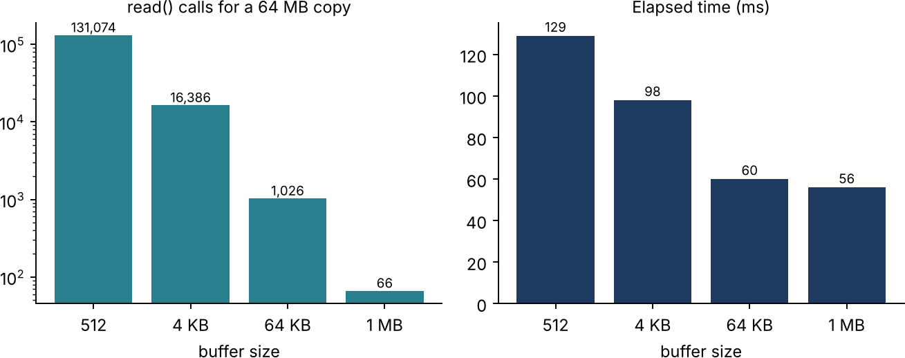

Figure 6.1 – System calls and time versus buffer size (64 MB copy)
    - Going from 512 B to 4 KB cuts the system calls 8x and the time by 24%; 64 KB cuts the time by a further 39%; beyond 64 KB the gain is small (0.060 -> 0.056 s) because the cost becomes dominated by the data copy, not by the call overhead.
    - Library buffering turns 67 million potential calls into 16,386, but a 1-byte fread loop still burns 1.4 s of user CPU in 67 million library calls, so a good buffer size matters even with stdio.

Recommended buffer size for the hospital's backup program
64 KB (between 64 KB and 256 KB): it achieves 93% of the best time seen (0.060 s vs 0.056 s at 1 MB) with only 1,026 calls and a buffer that fits in the L2 cache. Larger buffers waste memory and cache with no meaningful gain; buffers of 4 KB or less add a lot of kernel time. The backup also benefits from reading sequentially (read-ahead) and from fsync() only at the end.

Alternative concept: memory-mapped files (mmap)
int
in
=
open(src,O_RDONLY),
out
=
open(dst,O_RDWR|O_CREAT|O_TRUNC,0644);

fstat(in,&st); ftruncate(out, st.st_size);
char *s = mmap(0, st.st_size, PROT_READ, MAP_PRIVATE, in, 0);
char *d = mmap(0, st.st_size, PROT_READ|PROT_WRITE, MAP_SHARED, out, 0);
memcpy(d, s, st.st_size); // page faults load pages on demand

munmap(s, st.st_size); munmap(d, st.st_size);
Criterion | read()/write() with buffer b | mmap
System calls | about n/b reads + n/b writes: O(n/b) | a few (open, fstat, mmap, munmap, close): O(1). Measured with strace  -c: no read()/write() of data; about 45 calls in total, mostly program start-up (10 mmap, 3 munmap, 4 openat)
Copying | Kernel page cache -> user buffer -> kernel (2 copies) | Page cache mapped directly into user space (about 1 copy, in memcpy); but page faults cost time (one per 4 KB page, n/4096)
Memory for very large files | b bytes only, regardless of file size (space O(b)) | Virtual address space O(n); physical use is on demand and pageable, but a 1 TB file needs a 64-bit address space and error handling for I/O faults (SIGBUS)
Measured time (64 MB) | 0.060 s (64 KB) | 0.089 s
mmap removes the system calls but, for a sequential one-time copy, its page faults made it slower than a 64 KB read/write loop here. It is best for random access to large read-mostly files, so for the backup program a 64 KB read/write loop is retained.
Evidence: Measured system-call counts and times for different buffer sizes (6.4) with the recommendation (6.5).

Task 7 – Process Control System Calls

  - fork(), exec(), wait() and exit()

Call | What it does
fork() | Creates a child process that is a copy of the caller (own PID, copy-on-write memory, same open files). Returns the child's PID to the parent and 0 to the child, -1 on error.

Call | What it does
exec() family (execlp, execve) | Replaces the current program image (code, data, stack) with a new program; PID and open files stay. It returns only on failure.
wait() / waitpid() | Parent blocks until a child terminates and collects its exit status (macros WIFEXITED, WEXITSTATUS); this also lets the kernel free the child's process-table entry.
exit() / _exit() | Terminates the process with a status code; exit() runs atexit handlers and flushes stdio buffers first, _exit() terminates immediately.

How a shell runs a command

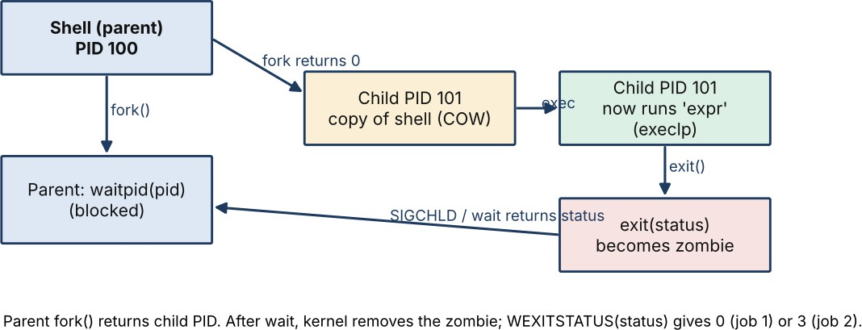

Figure 7.1 – Process diagram: shell runs 'expr 6 * 7' with fork, exec, wait
The shell reads the command line, calls fork(); the child calls exec() to become the requested program; the parent calls waitpid() and receives the status. The shell stores WEXITSTATUS(status) in $? (0 = success, 127 = command not found, as in the TODO). In job 1, expr prints 42 and exits with 0; in job 2 the child exits with 3.

Zombie and orphan processes
    - Zombie: a child that has terminated but whose parent has not yet called wait(); only its process-table entry (PID, exit status) remains. A long-running parent that never waits can leak zombies and exhaust PIDs. The OS removes the zombie when the parent waits, or when the parent exits.

    - Orphan: a child whose parent has exited while the child still runs. The kernel re-parents it to init (PID 1) or systemd, which waits for it, so orphans do not become permanent zombies.
  - Why fork() + exec() rather than one create-process call
Splitting creation from loading lets the child change its environment between the two steps (redirect stdin/stdout, set up pipes, change directory or user, set limits) using ordinary system calls, then exec the program. A single CreateProcess-style call needs a long parameter list for every such option (as in Windows). fork() is cheap through copy-on-write, and the parent keeps full control.

Complete the code – TODO 1
The given program uses the variables pid and status without declaring them, so int status; and pid_t pid; were added at the top of main(). The TODO was replaced with:
pid = fork(); if (pid == 0) {
execlp("expr", "expr", "6", "*", "7", (char *)NULL); exit(127); /* only reached if exec fails */
}
waitpid(pid, &status, 0);
printf("job 1 exit status %d\n", WEXITSTATUS(status));
Output (identical to the expected output):
shell: running job 1 42
job 1 exit status 0 shell: running job 2 job 2 exit status 3

Why stdout is flushed before each fork()
A child created by fork() gets a copy of the parent's unflushed stdio buffer. If the buffer is not empty at fork() time, the text would be output once by each process that later flushes it, which gives duplicated lines and a wrong order relative to the child's

own output. Flushing makes the buffer empty at fork() so each line is written exactly once.

Experiment: remove the second fflush, use exit(3), redirect to a file
Command: ./shell_noflush > out_file.txt. When stdout is a file, stdio is fully buffered, so at the second fork() the buffer still contains "job 1 exit status 0\nshell: running job 2\n". The child's exit(3) runs the exit handlers and flushes its inherited copy of the buffer, and the parent later flushes the original, so these lines are written twice. Observed output:
shell: running job 1 42
job 1 exit status 0 shell: running job 2 job 1 exit status 0 shell: running job 2 job 2 exit status 3
Both "job 1 exit status 0" and "shell: running job 2" appear twice. On a terminal (line buffered; run via script, which provides a pseudo-terminal) every line is flushed immediately at the newline, so there is no duplication, which is why the bug appears only on redirection. _exit(3) would not flush, which is why the original program is correct.
  - Alternative concept: posix_spawn() or threads

Criterion | fork() + exec() | posix_spawn() | Threads (pthread_create)
Time to start 1,000  commands | Measured fork+wait about 137 µs each, i.e. about 0.14 s for 1,000 with a small parent (grows with parent memory: 1.8 ms each with a 64 MB parent) plus exec time | Typically close to or lower than fork for large parents because it uses vfork-like creation (no page-table copy): O(1) in parent size | About 46-55 µs each, about 0.05 s per 1,000, but threads cannot run a different program without exec

Criterion | fork() + exec() | posix_spawn() | Threads (pthread_create)
Memory copied/shared | Page tables copied, pages shared copy-on-write: O(mapped pages) for fork; replaced entirely at exec | No copy of the parent's address space | Share the whole address space, heap and open files; only a new stack (8 MB virtual) and registers
Isolation | Full: separate address space, one command's crash cannot damage another | Full (separate process) | None: a bug or a crash in one thread kills all commands; one can overwrite another's memory
Conclusion: a shell must isolate commands, so processes are right; for a server starting thousands of programs with a very large parent, posix_spawn() is the better engineering choice.
Evidence: Working shell-like program (Task07/shell.c), process diagram (7.2), output and evaluation.

Task 8 – CPU States and Protection

  - User mode, kernel mode, privileged instructions
A hardware mode bit distinguishes kernel mode (0) from user mode (1). Applications run in user mode and cannot execute privileged instructions such as I/O instructions, enabling/disabling interrupts, setting the timer, modifying the MMU or page tables, and halting the CPU. Trying to do so raises a trap to the kernel, which terminates the program. The only legal way to obtain privileged services is a system call, which switches the mode bit to kernel mode while running OS code, then back.

Interrupts, traps and the timer
    - Interrupt: an asynchronous signal from hardware (sensor ready, disk done, network packet); the CPU saves its state, jumps through the interrupt vector to the handler, then resumes.
    - Trap (exception): a synchronous software-generated event (system call, divide by zero, page fault, illegal instruction).

    - Timer interrupt: a hardware timer, programmed by the OS, interrupts at fixed intervals (for example 1-10 ms) so the kernel regains control from a program stuck in a loop; it is the basis of time-slicing and of the monitors' periodic scheduler tick.

What if any program could disable interrupts?
A faulty or malicious program (for example a buggy extra application on a monitor) could disable interrupts and never re-enable them: the sensor interrupt and timer would never reach the OS, so abnormal readings would not be noticed, the alarm task would never be scheduled, and the watchdog could not reset the system, so the monitor would be dead until power-cycled, with the patient unprotected. This is why the instruction is privileged and why only short, bounded critical sections in kernel code disable interrupts.

How one program is stopped from reading another's memory
The memory management unit (MMU) translates every virtual address using the process's page table (or, on simple MCUs, a memory protection unit with base/limit regions). Entries carry permission bits (read, write, execute, user/supervisor). An address outside the process's pages or with a wrong permission triggers a trap (segmentation fault), and the OS kills the offending process. Only the kernel (privileged) can change the page-table base register, so a program cannot grant itself access.

Alternative concept: polling instead of interrupts on the monitor
/* polling */ while (1) {
v = read_sensor();
/* interrupt-driven */ void sensor_isr(void) {
v = read_sensor();
if (abnormal(v)) alarm();
if (abnormal(v)) alarm(); // runs at once
sleep(T); // polling interval } }
} // CPU sleeps between events

Criterion | Polling every T ms | Interrupt-driven
Worst-case delay before an  abnormal reading is noticed | Up to one full interval T (plus processing); for T = 5 ms the worst case is 5 ms, and polling must be faster than the 10 ms requirement, for example T <= 2-5 ms (O(T)) | Interrupt latency only: a few microseconds (about 1-20 µs)  + handler; O(1), independent of event rate
CPU time wasted | The CPU wakes 1/T times per second whether or not there is an event. At T = 1 ms and 5 µs per check: 1,000 x 5 µs = 0.5% CPU, with 100% duty when polling in a tight loop. 500 monitors waste measurable power | CPU is idle (sleep) until an event; work done = number of events
Power | Prevents deep sleep; hurts battery operation during transport | Allows low-power sleep between samples
Use | Acceptable when events are very frequent (high-rate streams) and the poll cost is lower than the interrupt cost | Best for rare, urgent events such as alarms
Polling is simpler and has no interrupt overhead, but its worst-case delay is bounded only by T and it wastes energy, so interrupts are retained for the alarm path.
Evidence: Explanation of CPU modes, interrupts and protection applied to monitors, with polling comparison.

Task 9 – Memory Hierarchy and I/O Systems

  - Memory hierarchy

Level | Typical access time | Typical size | Hospital use
Registers | < 1 ns | about 1 kB | Working values of the running task
L1 cache | about 1 ns | 32-64 kB per core | -
L2 / L3 cache | 4-20 ns | 256 kB-64 MB | Hot record indexes

Level | Typical access time | Typical size | Hospital use
Main memory (DRAM) | 60-100 ns | 16 GB-2 TB | Database buffer pool, current monitor readings, image slices being processed
SSD (NVMe) | 20-100 µs | 0.5-8 TB | Active patient records, database logs, recent MRI studies
Hard disk | 5-10 ms | 1-20 TB | Archived MRI images, older records, backups
Network storage  / cloud | 0.5-10 ms+  (LAN), 20-200 ms (WAN) | Practically unlimited | Off-site backup, shared records with partner hospitals

Where to keep each kind of data

Data | Placement | Reason
Monitor readings | RAM ring buffer on the monitor (last minutes) and periodic flush to the database | Needs sub-millisecond access; old values are archived
Patient records | SSD-backed database on the cluster, hot rows in the RAM buffer pool, replicated | Must be fast and durable, small relative to capacity
MRI images (hundreds of MB each) | Working set in RAM/NVMe during processing; finished studies on a large disk or network storage; old studies on cold storage | Too big and too numerous for RAM/SSD, accessed rarely after reporting

Programmed I/O, interrupt-driven I/O and DMA
    - Programmed I/O: the CPU polls the device status and copies each word itself: simplest, wastes CPU.
    - Interrupt-driven I/O: the device interrupts when ready; CPU does other work in between but still copies each word and handles an interrupt per unit.
    - DMA: the DMA controller moves a block between device and memory without the CPU and interrupts once at completion. Chosen for the MRI scanner and

disks. Monitors use interrupt-driven I/O for the sensor sample (small data, low rate).

Effect of caching on record look-up
Effective access time EAT = h x t_cache + (1 - h) x t_miss. With a RAM cache of 0.1 µs, an SSD miss of 100 µs and a hit ratio h = 0.95: EAT = 0.95 x 0.1 + 0.05 x 100 =
5.1 µs, versus 100 µs without cache: about 20x faster. At h = 0.99 it is 1.1 µs (90x). Over a hard disk (10 ms) the gain is even greater. Look-ups of recently used records are served from memory.

Alternative concept: interrupt-driven I/O (one interrupt per word) for the MRI scanner
Assumptions: 500 MB = 524,288,000 bytes, word = 4 bytes, interrupt service about 2 µs, DMA block 64 KB, DMA setup + completion interrupt about 5 µs.

Criterion | Interrupt per word | DMA
Number of interrupts | 524,288,000 / 4 = 131,072,000  interrupts (O(n)) | 524,288,000 / 65,536 = 8,000  interrupts (O(n/block))
CPU time | 131,072,000 x 2 µs = about 262 s of CPU time, which means the CPU cannot keep up if the scanner delivers data faster than that rate | 8,000 x 5 µs = about 40 ms of CPU time; the transfer itself runs on the DMA hardware
Memory buffers | Small device buffer (one word/FIFO) plus the destination memory | Whole 64 KB (or scatter-gather) buffers, double-buffering: 2 x 64 KB = 128 kB extra for overlapping
DMA cuts CPU involvement by about 6,500x in this model, at the cost of a little buffer memory and DMA set-up; interrupt-driven word transfers are therefore rejected for MRI images.
Evidence: Data-placement plan (9.2) and I/O method per device (9.3), using typical access times (9.1).

Task 10 – Measure and Compare

All measurements were taken on Ubuntu 24.04, gcc 13.3, 2 vCPUs (virtual machine). Absolute numbers will differ on your computer, and the VM adds noise, but the trends are what matter. Sources: Task10/copybench.c and Task10/procthread.c.

System calls for different buffer sizes (strace -c, 64 MB copy)

Buffer | read() calls | write() calls | Formula n/b
512 B | 131,074 | 131,073 | 67,108,864 / 512 =  131,072
4 KB | 16,386 | 16,385 | 16,384
64 KB | 1,026 | 1,025 | 1,024
1 MB | 66 | 65 | 64
1 B (1 MB file) | 1,048,578 | 1,048,577 | 1,048,576
Counts match n/b plus a handful of start-up calls, confirming the analysis of Tasks 5-
6. Note that strace slows the program down a great deal, so strace is used for counting, and the time command for timing. (For 4 KB, strace's own call-time column sums to 0.57 s, against 0.098 s total elapsed when untraced.)

User and kernel time (time command)

Buffer | real | user | sys | sys share
512 B | 0.129 s | 0.024 s | 0.104 s | 81%
4 KB | 0.098 s | 0.008 s | 0.073 s | 74%
64 KB | 0.060 s | 0.000 s | 0.043 s | 72%
1 MB | 0.056 s | 0.000 s | 0.035 s | 63%
fread, b=1 | 1.517 s | 1.433 s | 0.056 s | 4%

With direct read/write the work is mostly kernel time (copying and call handling); the many small calls (512 B) double the kernel time compared with 64 KB. The stdio b=1 case reverses the picture: kernel time is small (library buffering) but the user time is
1.4 s because of 67 million fread/fwrite calls.

Creating 1,000 processes (fork) vs 1,000 threads

Parent heap size | 1,000  fork()+wait | per fork | 1,000  pthread_create+join | per thread | Ratio
0 MB  (small) | 136.5 ms | 136.5 µs | 46.5 ms | 46.5 µs | 2.9x
64 MB | 1,812.6 ms | 1,813 µs | 49.1 ms | 49.1 µs | 37x
256 MB | 6,382.8 ms | 6,383 µs | 52.3 ms | 52.3 µs | 122x
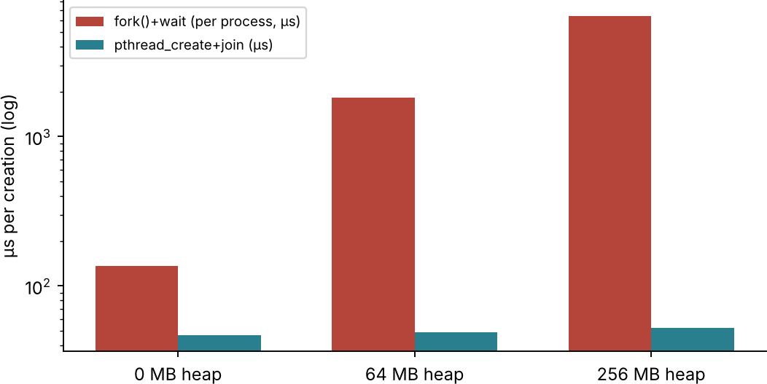

Figure 10.1 – Creation time per process and per thread
(A second run with a small parent gave 141.5 ms and 55.2 ms: the same shape.)

Do the measurements support the earlier judgements?
    - Support: system-call count falls as n/b (Task 5-6); a system call is about 80x a function call (Task 6); buffering and DMA-like batching gain is real; process creation is much more expensive than thread creation (Task 7).
    - Refinement: there are diminishing returns, so 64 KB is as good as 1 MB; mmap, expected to be fastest because it needs few calls, was slower (0.089 s) than a 64

KB loop because of page faults; fork cost depends on the parent's size, so the claim 'fork is cheap because of copy-on-write' holds only for small parents.
    - Limits: results come from a VM with 2 vCPUs and a warm page cache (files read from memory, not disk); a cold disk read would dominate (Task 9 numbers).

Alternative concept: threads instead of processes

Criterion | 1,000 processes | 1,000 threads
Creation time | 137 µs-6.4 ms each depending on parent size: O(mapped pages) | about 46-52 µs each, essentially independent of the parent size: O(1)
Memory used | Each process has its own page tables, kernel structures and (as it writes) private copies of pages; the shared pages are copy-on-write only until modified | Each thread needs only a stack (default 8 MB virtual, a few kB physical touched) + a small kernel structure; code, heap, globals and files are shared
Why the difference | Process = separate address space: page tables must be duplicated and write-protected for COW, file table copied | Threads share the address space, page tables and file descriptors, so nothing is copied; this is also why one thread can corrupt the others
Evidence: Tables of measured results (10.1-10.3) compared with expectations (10.4), differences explained in 10.5.

Task 11 – Recommended Operating-System Plan

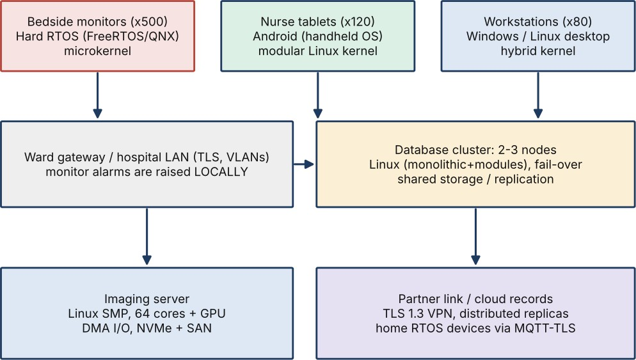

Figure 11.1 – Recommended architecture

The plan

Environment | OS type and structure | Key services | Protection | I/O method
Bedside monitor (500) | Hard RTOS, microkernel (QNX-class) or FreeRTOS + MPU; fixed priorities | Sensor I/O, alarm task, watchdog, minimal TLS network stack; no GUI/FS/accounting | Secure boot, signed firmware, MPU regions, privileged-only interrupt control | Interrupt-driven; DMA for ECG  sample blocks
Nurse tablet (120) | Handheld OS (Android-class), Linux kernel with modules | Touch GUI, Wi-Fi, power management, push alarms | App sandbox, disk encryption, MDM, remote wipe, per-app permissions | Interrupt-driven, DMA for flash
Workstation (80) | Desktop OS (hybrid kernel / Linux) | Full GUI, EHR  client, printing | User accounts, role-based access, patching, AV/EDR | Interrupt + DMA

Environment | OS type and structure | Key services | Protection | I/O method
Database server | Linux monolithic  + modules in a 2-  3 node cluster with fail-over | Journaling FS, transactions, cluster heartbeat, audit logging | MAC  (SELinux), encryption at rest, audit, least privilege | DMA, NVMe, RAID;  buffer cache
Imaging server | Linux SMP, 64 cores + GPU, NUMA aware | Job scheduler, large-file FS, GPU drivers | Isolated VLAN, signed jobs | DMA /  scatter-gather; 64 KB+  blocks
Partner link | Distributed record service: replicated database over TLS VPN | Name service, replication, authentication (Kerberos/OAuth) | Mutual TLS, VLAN, full audit | Network storage via sockets

Evidence from this analysis
    - A system call costs about 110 ns versus 1.4 ns for a function call (Task 6), so monitor drivers should be small and batch their I/O.
    - A 64 KB buffer reaches 93% of the best copy speed (Task 6), so it is used by the backup and imaging pipeline.
    - Interrupt/DMA instead of per-word I/O reduces CPU work by about 6,500x for MRI data (Task 9); polling adds up to T of alarm delay (Task 8).
    - Process creation grows with memory size while threads stay at about 50 µs (Task 10): the monitor's tasks are threads/tasks of one RTOS image, the database server uses processes for isolation.

Limitations and risks
    - Heterogeneity: four or five OS families need more skills, patch processes and testing; mitigate with central device management and a standard network protocol.
    - RTOS certification: medical regulation (IEC 62304) requires documented validation; QNX-class systems are licensed commercial products.

    - Cluster complexity: split-brain, shared-storage failure; needs fencing and regular fail-over drills.
    - Measurements are from a VM with warm caches; hospital hardware needs re-measuring, particularly 10 ms alarm latency on the real monitors.
    - Security: the more devices networked, the more attack surface; segmentation is mandatory.

Suitability for the group of three hospitals
The plan scales: monitors and tablets are per-ward and need only more gateways; the database cluster grows by adding nodes or a replicated cluster per hospital; shared records use the distributed layer with replication and a global identity service. Two things need attention: WAN latency (cross-hospital queries tens of ms, so keep local reads local) and a common patient-ID/identity scheme.

Alternative concept: virtual machines on two large servers

Criterion | Separate physical machines | VMs on two large servers
Response time for monitors | Real-time OS on dedicated hardware: deterministic, microsecond latency | A hypervisor adds scheduling and trap-and-emulate delay and jitter (tens to hundreds of µs, worse under contention from other VMs); can break the 10 ms hard guarantee. Monitors therefore must stay on physical hardware (or use a real-time hypervisor)
Memory/CPU overhead | None beyond the OS | About 2-10% CPU and a per-VM memory cost (guest kernel images, duplicated caches): O(V x S) where V  = number of VMs; offset by consolidating idle capacity (higher utilisation)

Criterion | Separate physical machines | VMs on two large servers
Reliability | Failure is isolated to one machine; a bigger fleet | Consolidation: the failure of one physical server takes down several VMs, so live migration/HA between 2 servers is needed; hypervisor bug or compromise affects all VMs. Easier backup, snapshots and rollback
Administration | Many boxes | Fewer boxes, faster provisioning
Decision: use VMs for workstation back-ends (VDI), tablets' management, test systems and parts of the application tier; keep the monitors on dedicated RTOS devices and the database cluster on separate physical nodes with fail-over.
Evidence: Technically justified plan (11.1) with support from measurements (11.2).

Task 12 – Day-4 Design Challenge: Re-evaluate and Adapt the Design
Changed requirement: remote monitoring devices in patients' homes send readings over the internet, and patient records move to a cloud service shared with partner hospitals.

Impact Analysis (2 marks)

Area | Affected? | How
OS types | Yes | A new environment appears: home monitors (embedded RTOS, battery or mains, consumer Wi-Fi). The distributed/cluster types now include cloud infrastructure (virtualised, multi-tenant). The hospital database cluster becomes one of several replicas.
Services | Yes | Communication becomes critical (reliable messaging over unreliable links, retry, store-and-forward); updates must be remote (OTA); resource allocation moves to autoscaling in the cloud; accounting/audit and billing across organisations.
Protection and security | Most affected | The trust boundary moves from the hospital LAN to the open internet: device identity, mutual TLS, data encryption at rest in a third-party cloud, key management, legal data residency/privacy; patients' home routers cannot be trusted.

Area | Affected? | How
Response time and reliability | Yes | Alarm path now crosses the internet with unbounded latency and outages: the home device must alarm locally; cloud alerts cannot meet 10 ms (typical round trip 20-200 ms and can fail).
Unchanged | No | Bedside monitors, tablets, workstations, imaging server inside the hospital; the choice of RTOS and structure for monitors.

Evaluation of the Original Design (2 marks)

Requirement | Does the original plan support it? | Evidence and reasoning
Response time | Partly | Hospital monitors meet 10 ms because alarms are local; but a design in which alarms depend on a hospital server reachable over the internet cannot be bounded. Our measured system-call and interrupt analysis applies only to the local RTOS, not to the network.
Reliability | Partly | The database cluster fails over within seconds but a single-site cluster is a single point of failure for 3 hospitals plus homes; the internet link and the cloud provider add new failure modes.
Security | No | Original security assumed a trusted LAN with VLANs and the 'partner link' as the only external edge. Thousands of home devices and a cloud store enlarge the attack surface: each device is a potential entry point (Task 4 protections are not enough alone).
Scalability | Partly | The cluster scales by adding nodes, but the new load is thousands of small, constantly arriving device messages and cross-organisation queries, a different pattern from the original.
Conclusion of the evaluation: the original design is *sound at its core* (RTOS monitors, handheld tablets, desktop workstations, clustered database) but is not sufficient at the edges: it needs a home-device class, an edge/cloud tier and a new security model. It should therefore be *modified*, not redesigned.

Adaptation or Redesign (2 marks)

Component | Revised plan
Home monitoring device | Embedded hard/firm RTOS (FreeRTOS, Zephyr or QNX): local sensing and local alarm (buzzer, phone notification) within 10 ms independent of the internet; secure boot, signed OTA updates, hardware crypto, sleeps between samples for battery.
Home gateway/phone | Handheld OS app (Android/iOS) as a store-and-forward gateway: buffers readings during outages and sends them over TLS 1.3 with a device certificate (MQTT-TLS or HTTPS).
Cloud records service | Distributed system: replicated database across several availability zones and hospitals (a cluster of clusters), Linux on virtual machines/containers; strong consistency for medication and allergy data, eventual consistency for non-critical data; identity by OAuth2/OIDC and mutual TLS; encryption at rest with hospital-controlled keys; full audit.
Hospital core | Retain: bedside RTOS, tablets, workstations, imaging SMP server, on-premise cluster as the primary of record or as a replica; a local cache keeps the hospital running if the cloud or the internet fails (degraded mode).
Security model | Zero-trust: every device and user is authenticated for every request; segmentation; intrusion detection; patching and certificate rotation; privacy compliance.

Evidence-Based Defence (2 marks)
  - Decision: MODIFY. The core design is supported by this report's analysis and measurements: the 10 ms alarm requirement can only be met by a real-time OS with interrupts (Task 8, Task 1.5); system-call and process costs (Tasks 6 and 10) favour small RTOS tasks on devices and heavy processing on servers; DMA and 64 KB buffers remain the right I/O choices for images (Tasks 6 and 9). None of this changes with the cloud, so a full redesign would throw away validated parts.
  - Why not RETAIN? Network latency (20-200 ms) is 2-20x the 10 ms deadline, so home devices must alarm locally, and the trust model changes (Section B). A single on-premise cluster does not give the availability required by 3 hospitals and homes.

  - Why not REDESIGN? Moving the monitors' alarms or the database entirely to a general cloud VM would add hypervisor jitter and network dependence (Task 11.5), breaking the safety requirement.

Trade-off | Gain | Cost
Local alarm on home device | Safety independent of the internet | More expensive device, firmware to maintain
Cloud replicated records | Availability, easy sharing, elasticity | Dependence on a provider, WAN latency, privacy and compliance work
Zero-trust and encryption | Smaller attack surface | CPU and battery use, certificate management complexity
Edge buffering | No data lost during outages | Delay in delivering non-urgent data; storage on gateway
Final decision: retain the hospital design, add an embedded real-time OS on home devices with local alarms, a store-and-forward gateway, a replicated distributed cloud record service with strong security and a degraded-mode local cache. This keeps the proven safety properties while supporting the new requirements.
Evidence: Impact analysis (A), evaluation (B), revised plan (C) and defence with trade-offs (D).

Appendix – Source Code, Commands and GitHub Notes

  - Suggested repository layout and README
CSA04-<RegisterNumber>-Assignment1/ README.md
Task05/ strace_cat.txt
Task06/ copy_file.c syscall_cost.c output.txt strace_c.txt Task07/ shell.c shell_noflush.c output.txt out_file.txt Task10/ copybench.c procthread.c results.txt (screenshots) Task01-04, 08-09, 11-12/ report sections / diagrams
Commands used (README):

gcc -std=c11 -Wall -Wextra -pthread -o copy_file Task06/copy_file.c &&
./copy_file
strace -c -e trace=read,write -f ./copy_file
gcc -std=c11 -Wall -Wextra -o shell Task07/shell.c && ./shell
./shell_noflush > out_file.txt; cat out_file.txt
gcc -std=c11 -O1 -Wall -Wextra -pthread -o procthread Task10/procthread.c &&
./procthread 0
bash: time ./copybench rw big.dat out.dat 65536
Remember to commit at least once per task (git add TaskNN; git commit -m "Task NN
...") and push, since the commit history is checked.

  - Complete listing – Task06/copy_file.c (TODO 1 filled in)
#define _POSIX_C_SOURCE 200809L #include <stdio.h>
#include <fcntl.h> #include <unistd.h>
/* Copy src to dst with the read() and write() system calls, using a buffer of bufsize bytes. Returns the number of read() calls made, or -1 on error. */ long copy_file(const char *src, const char *dst, size_t bufsize)
{
char buf[8192];
int in = open(src, O_RDONLY); if (in < 0) return -1;
int out = open(dst, O_WRONLY | O_CREAT | O_TRUNC, 0644); if (out < 0) { close(in); return -1; }
long calls = 0; ssize_t n;
// TODO 1: Loop: read up to bufsize bytes into buf (count every read call in calls);
// stop when read returns 0 (end of file) or -1; write exactly the n bytes that
// were read

while (1) {
n = read(in, buf, bufsize); calls++;
if (n <= 0) break;
if (write(out, buf, (size_t)n) != n) { calls = -1; break; }
}
close(in); close(out); return calls;
}
int main(void)
{
FILE *f = fopen("records.dat", "w"); /* a 10,000-byte test file */ for (int i = 0; i < 10000; i++) fputc('A' + i % 26, f);
fclose(f);
size_t sizes[] = {1, 512, 4096}; for (int i = 0; i < 3; i++)
printf("buffer %4zu bytes: %5ld read() calls\n", sizes[i], copy_file("records.dat", "copy.dat", sizes[i]));

unlink("records.dat"); unlink("copy.dat"); return 0;
}

Complete listing – Task07/shell.c
#define _POSIX_C_SOURCE 200809L #include <stdio.h>
#include <stdlib.h> #include <unistd.h>

#include <sys/wait.h> int main(void)
{
int status; pid_t pid;
printf("shell: running job 1\n");
fflush(stdout); /* empty the buffer before fork() */
// TODO 1
pid = fork(); if (pid == 0) {
execlp("expr", "expr", "6", "*", "7", (char *)NULL); exit(127);
}
waitpid(pid, &status, 0);
printf("job 1 exit status %d\n", WEXITSTATUS(status)); printf("shell: running job 2\n");
fflush(stdout); pid = fork();
if (pid == 0) _exit(3); /* a child that fails with code 3 */ waitpid(pid, &status, 0);
printf("job 2 exit status %d\n", WEXITSTATUS(status)); return 0;
}

Listing – Task10/procthread.c
#define _POSIX_C_SOURCE 200809L #include <stdio.h>
#include <stdlib.h> #include <pthread.h> #include <unistd.h>

#include <time.h> #include <sys/wait.h>
static double now(void){struct timespec t;clock_gettime(CLOCK_MONOTONIC,&t);return t.tv_sec+t.tv_nsec/1e9;}
static void *thr(void *a){(void)a;return NULL;} int main(int argc, char **argv)
{
int N = 1000, mb = argc > 1 ? atoi(argv[1]) : 0; char *big = NULL;
if (mb) { big = malloc((size_t)mb<<20); for (size_t i=0;i<((size_t)mb<<20);i+=4096) big[i]=1; }
double t0 = now();
for (int i = 0; i < N; i++) { pid_t p = fork(); if (p == 0) _exit(0); waitpid(p, NULL, 0); }
double t1 = now();
for (int i = 0; i < N; i++) { pthread_t t; pthread_create(&t, NULL, thr, NULL); pthread_join(t, NULL); }
double t2 = now();
printf("parent heap %3d MB: 1000 fork+wait = %.1f ms (%.1f us each); 1000 pthread_create+join = %.1f ms (%.1f us each)\n",
mb, (t1-t0)*1e3, (t1-t0)*1e3/N*1e3, (t2-t1)*1e3, (t2-t1)*1e3/N*1e3); return 0;
}

